Оглавление

ЗАНЯТИЕ 3: 2

Занятие 6. Код Прюфера 3

Занятие 7. Алгоритм поиска в глубину и поиска в ширину 4

# ЗАНЯТИЕ 3:

Задание 1

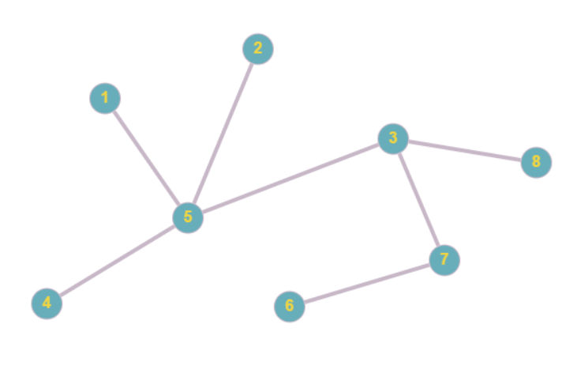

Задание 2:

|  |  |  |  |  |  |  |  |  |
| --- | --- | --- | --- | --- | --- | --- | --- | --- |
|  | 1 | 2 | 3 | 4 | 5 | 6 | 7 | 8 |
| 1 | 0 | 0 | 0 | 0 | 1 | 0 | 0 | 0 |
| 2 | 0 | 0 | 0 | 0 | 1 | 0 | 0 | 0 |
| 3 | 0 | 0 | 0 | 0 | 1 | 0 | 1 | 1 |
| 4 | 0 | 0 | 0 | 0 | 1 | 0 | 0 | 0 |
| 5 | 1 | 1 | 1 | 1 | 0 | 0 | 0 | 0 |
| 6 | 0 | 0 | 0 | 0 | 0 | 0 | 1 | 0 |
| 7 | 0 | 0 | 1 | 0 | 0 | 1 | 0 | 0 |
| 8 | 0 | 0 | 1 | 0 | 0 | 0 | 0 | 0 |

Задание 3:

|  |  |  |  |  |  |  |  |  |
| --- | --- | --- | --- | --- | --- | --- | --- | --- |
|  | 1 | 2 | 3 | 4 | 5 | 6 | 7 | 8 |
| A | 1 | 0 | 0 | 0 | 1 | 0 | 0 | 0 |
| B | 0 | 1 | 0 | 0 | 1 | 0 | 0 | 0 |
| C | 0 | 0 | 1 | 0 | 1 | 0 | 0 | 0 |
| D | 0 | 0 | 0 | 1 | 1 | 0 | 0 | 0 |
| E | 0 | 0 | 1 | 0 | 0 | 0 | 0 | 1 |
| F | 0 | 0 | 1 | 0 | 0 | 0 | 1 | 0 |
| G | 0 | 0 | 0 | 0 | 0 | 1 | 1 | 0 |

Задание 4:

|  |  |  |  |  |  |  |  |  |
| --- | --- | --- | --- | --- | --- | --- | --- | --- |
|  | 1 | 2 | 3 | 4 | 5 | 6 | 7 | 8 |
| 1 | 1 | 0 | 0 | 0 | -1 | 0 | 0 | 0 |
| 2 | 0 | 1 | 0 | 0 | -1 | 0 | 0 | 0 |
| 3 | 0 | 0 | 3 | 0 | -1 | 0 | -1 | -1 |
| 4 | 0 | 0 | 0 | 1 | -1 | 0 | 0 | 0 |
| 5 | -1 | -1 | -1 | -1 | 4 | 0 | 0 | 0 |
| 6 | 0 | 0 | 0 | 0 | 0 | 1 | -1 | 0 |
| 7 | 0 | 0 | -1 | 0 | 0 | -1 | 2 | 0 |
| 8 | 0 | 0 | -1 | 0 | 0 | 0 | 0 | 1 |

Задание 5

Без 1,4

|  |  |  |  |  |  |  |
| --- | --- | --- | --- | --- | --- | --- |
|  | 2 | 3 | 5 | 6 | 7 | 8 |
| B | 1 | 0 | 1 | 0 | 0 | 0 |
| C | 0 | 1 | 1 | 0 | 0 | 0 |
| E | 0 | 1 | 0 | 0 | 0 | 1 |
| F | 0 | 1 | 0 | 0 | 1 | 0 |
| G | 0 | 0 | 0 | 1 | 1 | 0 |

Без 1,5

|  |  |  |  |  |  |  |  |  |
| --- | --- | --- | --- | --- | --- | --- | --- | --- |
|  | 1 | 2 | 3 | 4 | 5 | 6 | 7 | 8 |
| E | 0 | 0 | 1 | 0 | 0 | 0 | 0 | 1 |
| F | 0 | 0 | 1 | 0 | 0 | 0 | 1 | 0 |
| G | 0 | 0 | 0 | 0 | 0 | 1 | 1 | 0 |

Задание 6

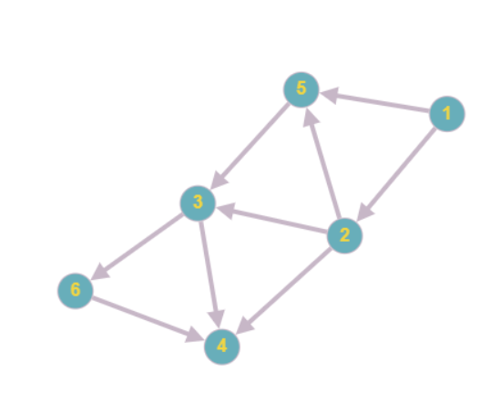

Задание 7

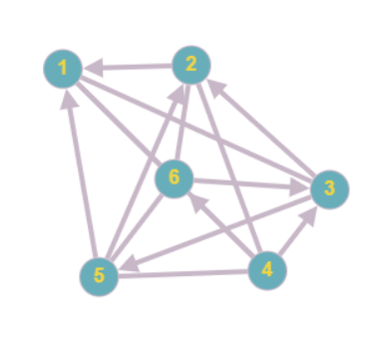

|  |  |  |  |  |  |  |
| --- | --- | --- | --- | --- | --- | --- |
|  | 1 | 2 | 3 | 4 | 5 | 6 |
| 1 | 0 | 0 | 1 | 1 | 0 | 1 |
| 2 | 1 | 0 | 0 | 1 | 0 | 1 |
| 3 | 1 | 1 | 0 | 0 | 1 | 0 |
| 4 | 1 | 1 | 1 | 0 | 1 | 1 |
| 5 | 1 | 1 | 0 | 1 | 0 | 1 |
| 6 | 1 | 1 | 1 | 0 | 1 | 0 |

Задание 8

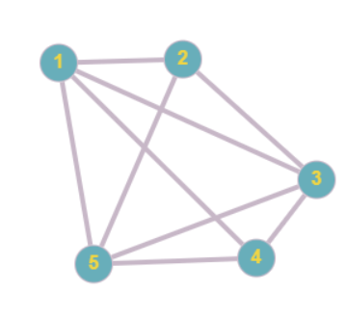

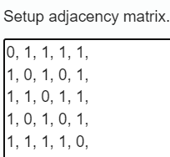

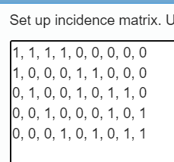

|  |  |  |  |  |  |
| --- | --- | --- | --- | --- | --- |
|  | 1 | 2 | 3 | 4 | 5 |
| 1 | 4 | -1 | -1 | -1 | -1 |
| 2 | -1 | 3 | -1 | 0 | -1 |
| 3 | -1 | -1 | 4 | -1 | -1 |
| 4 | -1 | -1 | -1 | 4 | -1 |
| 5 | -1 | -1 | -1 | -1 | 4 |

Задание 9

A – полный и колесо

B – полный и колесо

C - двудольный

# Занятие 6. Код Прюфера

Задание 1: Не понял задания

Задание 2: 2 5 6 5 8 5 6 9 8 11

Задание 3:

Задание 4:

# Занятие 7. Алгоритм поиска в глубину и поиска в ширину

Задача 1.

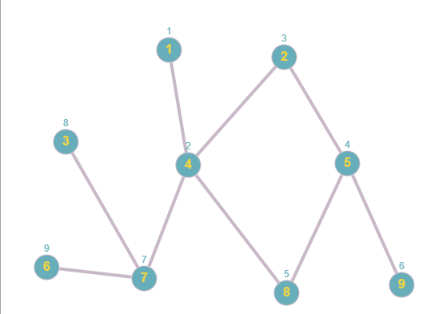

В Глубину: 1-4-2-5-8-9-7-3-6

В ширину: 1-4-2-7-8-5-3-6-9

Задача 2:

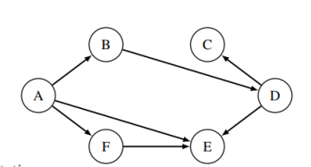

В Глубину: A-B-D-C-E-F

В ширину: A-B-E-F-D-E-C

Задача 3: Полного

Задача 4: Простой цикл из 3-х вершин

Задача 5: Полного